Indian Institute of Technology Mandi

Mandi, Himachal Pradesh

\ . 'l.'cdeuuloyy· lifoncli
- )FTIc61
. @411,:fot
ct i f.I l

No. IIT Mandi/28th BoG/2019/ Date: 09.01.2020

To

Dean (Faculty) IITMandi

Dear Sir,

Please see below extract of Minutes of the 28th Board meeting held on 13th December, 2019 vide item no. 28.2.4 duly approved by the Chairperson, BoG for your kind information and further necessary action

C9,PYfo:
LA'. Sr. Superintendent (Faculty Estb. & Admn.), IIT Mandi
Q9Jl9:- \ Ci \z...O.
(K. K. Bajre)
Registrar

Item No.: BoG-28.2.4
To consider. the Recruitment and Performance Review process of Faculty members.
The process followed by the Institute for the recruitment and performance review of faculty is well structured. Since inception of the Institute, the process has been very successful in hiring of faculty and in nursing their academic growth. The Board of Governors had approved major aspects of these processes.
Dr. Tulika P. Srivastava presented the recommendations of the Committee comprising Dean (Faculty), Associate Dean (Faculty) and Chairperson, School of Computing and Electrical Engineering regarding detailed recruitment and performance review of faculty. The BoG also noted the comments of MHRD vide letter no. 16-8/2019-T.S.l dated 11th December, 2019.
After due deliberations, the Board noted the same and resolved to approve the proposed policy on the Recruitment and Performance Review process of Faculty members. Further, the Board approved, for Assistant Professor and Associate Professor, School Chair will be a member, if occupying a post higher than that of selection being made. Else, a senior faculty from School or other School in place of School Chair shall be a member of the Selection Committee. The Board

Indian Institute of Technology Mandi, Kamand Campus, Kamand, Mandi - 175075 (H.P.) Telephone No.01905-267015, Fax: 01905-267075, Email: registrar@iitmandi.ac.in
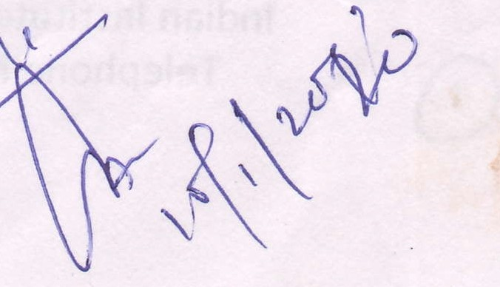

Indian Institute of Technology Mandi
,
!.l 'c.11 ¢"1
'ffilc,f

Mandi, Himachal Pradesh

also approved to authorize·the Director, as the Chairm of the Selection Committees to invite up to two experts over and above than prescribed in Section
17.5 of the Statutes from the approved panel of the experts. These experts would also participate in final recommendations. Refer Annexure - 1 & 2; Page 1 to 6.

No. IIT Mandi/28th BoG/2019/ Date: 09.01.2020

Indian Institute of Technology Mandi, Kamand Campus, Kamand, Mandi -175075 (H.P.) Telephone No.01905-267015, Fax: 01905-267075, Email: registrar@iitmandi.ac.in

Faculty Recruitment Process

  - The School Chair in consultation with the CIG chair presents the requirements of Faculty in the School to Institute Sta ding Committee (ISC). The ISC evaluates the proposal on merit for decision.
  - Institute website has rolling advertisement for most of the specializations of schools. However, specific areas approved by the ISC are 2dditionally advertised.
o Normal_ly:the applications are screened at two levels. The Director co11stitutes School FacLilty Screeni11g Comrnittee (SFSC) and Institute Faculty Sc eening CommHtec
. (IFSC); as_per the Statue 17.2.

  - The present compo ition of IFSC is as follows:

Chairperson - Director or a Professor nominated by him Member - Dean (Facuity)
Member - Chairperson of the concerned School Member - Chair of SFSC
Member(s) - Nominated by the Director

  - The SFSC a.fter screening of applications submits the recommended list of applicants to the IFSC through tlie School Chair. The SFSC may also screen the applications at
regular intervals even before the additional advertisement to search for applicants with exceptional academic track record and may include them in their
recommendations.

  - The IFSC may revise the norms for screening- used by SFSG, if required, and may advise it tq screen the applications again and ri1ay add c1dditional candidates. The minutes of meeting are approved by the Director.
- The D_i_rector constitutes the Selection Comrnittee. for each area/discipline as per Section 17 .(5)_of the Statutes in accordance with the panel approved hy BoG and fixes the interview date.
e IFSC approved candidates are invited to appear before the Selection Committee. The Selection Committee shall examine the credentials of all persons who have applied and may also consider other suitable names suggested, if any, by a member of the Selection Committee or brought otherwise to the notice of the Committee. The selection committee can invite those candldates who have not applied against the advertised position for the interview. The Selection Committee may interview/evaluate any of the candidates as it thinks fit and shall make its
. recommendations to the Chairperson BoG.

(j)

- As per the Section 17(5) of the Statues, the Selection Committee has members from the Panel of Experts as approved by BoG. The selection committee consists of three such BoG nominated experts.
- Since the Institute has organized its academic administration as Schools, each School covers a wide range of specializations and many sub-specializations. Covering each sub-specialization with three expert members in the Selection Committee may not be feasible for Schools. Further, the Institute struggles with accessibility problems as the air connectivity is not reliable. Many a times it disrupts the entire schedule of the Selection committee meeting.
Therefore, the Director, as the Chairman of the Selection Committees is authorized to invite up to two experts over and above th se prescribed in Section 17.5 of the Statutes from the approved panel of the experts. These experts would also participate in the final recommendations of the selection committee.
- For Assistant Professor and Associate Professor, School Chair will be a member, if occupying a post higher than that of selection being made. Else a senior faculty from School or other School in place of School Chair shall be a member of the Selection Committee.
- Selected applicants for the post of Assistant Professor Grade \I are offered an appointment on contract up to a period of five years, which may be extended.
- Assistant Professors Grade 11 may be moved to Assistant Professor Grade I and/or to higher pay level or cell or both as per approved pay scale based on the recommendation of the Performance Review Committee.

- The services of Assistant Professors Grade I, Associate Professor and Professors or equivalent positions who had appeared in the interview in person are required to go through probation of one year which may get extended based on the recommendation of the Performance Review Committee.

·• The services of Assistant Professors Grade I, Associate Professor and Professors on contract or equivalent positions on contract who had appeared in the interview in person may be regularized based on the recommendations of the Performance Review Committee or Selection Committee, as the case may be. For such Faculty. member probation shall be deemed to be complete, if service period on contract in the same pay level is more than the specified period of probation.
- Faculty member of any academic designation who had not been interviewed in- - person through Selection Committee (i.e. interviewed through tele/skype/video conferencing etc.) and had been selected normally on contract and who are required to appear before a Selection Committee for regularisation, are automatically shortlisted provided they appear within two years of joining the Institute.

  - Faculty member of any academic designation who had not been interviewed in­ person through Selection Committee (i.e interviewed through tele/skype/vid o conferencing etc.) their probation period may be deemed to .be complete after
regularization by the Selection Committee in which·they .appear in person -However.
this exemption shall be applicable o·nly if service period on con ract is in the same
pay level and the durati_on on contract is more than the specified period of probation.

  - In case the probation period is extended, the extended period shall not be counted for eligibility for higher post.
o Service of Faculty of any academic designation is liable to be terminated if the Performance Review Committee finds the performance unsatisfactory for consecutive two semesters.

  - Selection Committee meetii1gs may be organized more than once a year b9sed on the needs of the Schools. However, to address urgen_t needs of a school or to hire an­
exceptionally qualified applicant! there is provision for Adhoc Faculty Seiection Committee (AFSC) as per the Section 17.10 of the Statutes. This Committee may evaluate/interview the candidates and make a contractual offer of typical 2.:3 years which can be extended upto 5 years based on annual performanc reviews.

  - The present composition of the Ad-hoc Selection Committee is as follows: Director- Chairperson
Chair School(s) concerned - Member
{ or senior Faculty from School or other School in case·the post for which evaluation is being made is same or lower in status than that held by Chair School}
Dean Academics - Member Dean Faculty - Member Professor from School (s)
Professor from another School (s)
For other cases, Section 17.10 of the Statutes may be used to constitute such Adhoc Faculty Selection Committees.

Notwithstanding anything contained in above Recruitment process of Faculty members shall restrict any provision given in Statutes.
x x

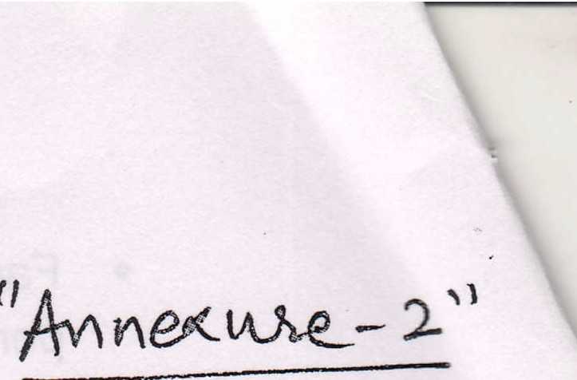
Faculty Performance Review Process

The main objectives the Performance Review to nurse academic career of the faculty, to ensure that a faculty excels in his/her chosen disciplinu and to share the expectations of the Institute. The present process of review for Assistant Professor is well structured and has served well Associate Professors also. Therefore, it is proposed to have review process approved by the BOG for entire Faculty cadre.
These reviews are also requirement for service related matters such as Probation Confirmation, Service Regularization, Placement in higher pay level etc.
Detailed steps are as follows:

    - Performance review of Assistant Professor, Associate Professor and Professor or equivalent positions be done annually, biennially and triennially, respectively.
    - There are several dimensions on which performance is reviewed. Four major dimensions are teaching, research (including research guidance and funding), contributions to Institute building & lnstt. Services. All faculty and persons in similar positions are expected to excel in at least two of these dimensions and to perform good in others.
    - Few other dimensions for performance review include Industry Interaction, Contributions to Government/Policy bodies, Social activities, Professional bodies and Nurturing of other educational Institutions. These dimensions are optional, though it is expected from Faculty member that they would normally be active in some of these also as their career advances.
    - The proportion of responsibilities of each Faculty member will depend upon the needs of the Institute, interests and capabilities of concerned Faculty member and will be dynamic in nature.
    - Faculty is required to submit Self-Assessment report in a prescribed format. This Self-assessment report has two parts. Part-A is for achievements already made and Part-8 is for the future plans. This assessment report forms the basis of the interaction during performance review.
o An introductory review meeting is to be held within 3 months of joining of a Faculty in the institute. The primary purpose of this interaction is to share institute's vision, mission, and immediate expectations and to know faculty immediate teaching and research plans. The Committee may give its advice in the context of proposed teaching and research plans.
C) These Performance Reviews may also be required for service related matter

and may synchronized accordingly.

- Following compositions are proposed for the Periodic Review Committees:
S.  No. | Review Purpose | Committee Composition
1. | New Faculty Interaction Meeting | - Director, (Chairperson)
....2. ·· |  | - Chairperson of concerned School(s) (Member)  {If the post for which review is being made is same or lower in status than that held by School Chairperson}
Periodic Review Meeting

_
- Professor/Associate Professor (Member)
{If the post for which review is being made is same or lower in status than that held by member}
 |  | - Invited member(s) of any designation, (optional) if desired by the Chairperson.
j Dean (Faculty) is authorized to constitute the ·
Review Committee.
, ... |  | ..

,

- Following compositions are proposed for the Review Committees for service related matters of Faculty members:
S. | Review Purpose | Committee Composition  - Director, (Chairperson)  - Chairperson of concerned School(s) (Member) {If the post for which review is being made lower in status than that held by School Chairperson, alternatively: Senior Faculty from School or other School}. -  - Professor/ Associate Professor (Member)  {If the post for which review is being made is same or lower in status than that held by member}  o Invited member(s) of any designation, (optional) if desired by the Chairperson.  oean (Faculty) is authorized to constitute the  v Review Committee.
No.  1--. - | Review for Probation Confirmation
2. | Review for movement to next pay level
!---  3. | ---·'---------------  Review of Assistant Professor /
 | Associate Professor / Professor on
 | Contract (to be regularized through internal committee)
 | Review Committee is empowered to recommend the extension or termination
 | or regularisation of contract.
4. | Assistant Professor/Associate Professor/Professor on Contract (to be
 | regularized through selection committee)
 | Review Committee is empowered to
 | recommend the extension of contract.

-

- Following is proposed for the regularization of Assistant Professor Grade II (on contract) to Assistant Professor Grade I:

s.  No. | Review  Purpose | Committee Composition
1 | Review for  regularization of Assistant | - Director, (Chairperson)  - Chairperson of concerned School (Member) {If the post for which review is being made lower in status than that held by School  Chairperson, alternatively: Senior Faculty from School or other School}.  C, Member from the School (nominated by ISC) (Member) {If the post for which review is being made is same or lower in status than that held by member}  .• Member of the ISC (Member) {of any academic designation} External expert from a panel of subject experts submitted by the  above member from the School (Member){of any designation}  Director/Dean (Faculty)ls authorized to constitute the Review Committee!
Professor Grade
II
 | ,

Based on the performance review meeting process the outcome will be shared by the Chairperson to Faculty members during and after the meeting through appropriate means/channel.

Notwithstanding anything contained in above Performance Review process of Faculty members shall restrict any provision given in Statutes.
· -

X: ·
.-x

